**______________________________**

**Software Requirements**

**Specification**

**for**

**DECENTRALISED AI TRIP GENERATOR**

**Version 1.0 approved**

**Prepared by Rohit Halsana**

**KIET Group Of Institutions**

**6/03/2025**

**Contents**

1. **Introduction ------------------------------------------------------------------------- 3**  
   1.1 Purpose of the Project  
   1.2 Scope of the Project  
   1.3 Product Perspective
2. **Overall Description ---------------------------------------------------------------- 4**  
   2.1 Purpose for SRS  
   2.2 Product Features  
   2.3 User Classes and Characteristics
3. **Specific Requirements ------------------------------------------------------------ 6**  
   3.1 Functional Requirements  
   3.2 Non-Functional Requirements
4. **External Interface Requirements** ----------------------------------------------- 7
5. **Other Requirements --------------------------------------------------------------- 8**  
   5.1 Legal and Ethical Concerns  
   5.2 Assumptions and Dependencies

## Introduction

### Purpose

* + - **Enhance Personalized Travel Planning** – Utilize AI to generate customized trip itineraries based on user preferences, real-time data, and dynamic factors like weather and local events.
    - **Ensure Security and Transparency** – Leverage blockchain to protect user data, enable decentralized payments via smart contracts, and store immutable reviews for trust and reliability.
    - **Empower Users with Decentralization** – Eliminate reliance on centralized travel platforms, giving users full control over their travel data and bookings through a secure and efficient system.

### Scope

* + - **AI-Powered Trip Planning** – Uses AI to generate personalized travel itineraries based on user preferences, budget, real-time data, and external factors like weather and local events.
    - **Blockchain Integration** – Ensures security, transparency, and decentralization through smart contracts, decentralized payments, and immutable user reviews.
    - **MERN Stack Development** – Utilizes MongoDB for data storage, Express.js for backend operations, React for the front-end interface, and Node.js for seamless interaction with decentralized networks.
    - **User Control and Privacy** – Eliminates reliance on centralized travel platforms, giving users full control over their data, bookings, and transactions.
    - **Key Features** – Includes user authentication, itinerary recommendations, secure bookings, peer-to-peer transactions, and a decentralized review system.
    - **Scalability and Future Growth** – Allows for AI enhancements, additional decentralized services, and multi-currency blockchain transactions in future iterations.

### Definitions, Acronyms, and Abbreviations

* + - **AI Model : Gemini API (1.5 Flash)**
    - **Frontend : React, JS**
    - **Backend : Firebase, NodeJS**
    - **Blockchain : Solidity**
    - **CRUD** - Create, Read, Update, Delete

### References

* + - IEEE SRS Guidelines
    - Research papers on Blockchain and Travelling Projects
    - Documentation on Blockchain and web development frameworks

## Overall Description

### Product Perspective

The **Decentralized AI Trip Generator** is an AI-powered travel planning platform that eliminates reliance on centralized systems, giving users full control over their data and bookings. It generates personalized itineraries based on preferences, budget, weather, and local events. **Blockchain integration** ensures secure transactions, decentralized payments via smart contracts, and immutable user reviews for transparency. Built using the **MERN stack**, it leverages MongoDB, Express.js, React, and Node.js for seamless functionality. The system supports **peer-to-peer interactions**, enabling direct communication between users and travel service providers. By removing intermediaries, it reduces costs while improving security and efficiency. Its **scalable design** allows future AI enhancements, expanded decentralized services, and multi-currency blockchain transactions. This makes it a **future-proof** solution for modern, secure, and adaptive travel planning.

### Product Features

* + - 1. **AI-Powered Itinerary Generation** – Generates personalized travel plans based on user preferences, budget, weather, local events, and real-time data.
      2. **Blockchain Security & Transparency** – Ensures secure transactions, decentralized payments via smart contracts, and immutable storage of user reviews.
      3. **Decentralized Data Control** – Eliminates reliance on centralized servers, allowing users to own and manage their travel data securely.
      4. **Smart Contract-Based Bookings** – Automates and secures travel bookings, payments, and refund processes using blockchain-based smart contracts.
      5. **Peer-to-Peer Network Integration** – Enables direct interactions between travelers, service providers, and AI models without intermediaries.
      6. **MERN Stack Architecture** – Utilizes MongoDB for data storage, Express.js for backend operations, React for an interactive front-end, and Node.js for seamless communication with decentralized networks.
      7. **Real-Time Updates & Dynamic Adjustments** – Adapts itineraries based on changing conditions such as weather, flight delays, and local events.
      8. **Decentralized Review & Rating System** – Stores user feedback on blockchain, ensuring authenticity and preventing manipulation.
      9. **Multi-Currency & Crypto Payment Support** – Allows transactions using various cryptocurrencies and fiat currencies via blockchain wallets.
      10. **Scalability & Future Expansion** – Designed for AI enhancements, additional decentralized services, and improved blockchain integrations.

### User Classes and Characteristics

1. **Individual Travelers** – Users planning personal or group trips who seek AI-generated, real-time itineraries with secure and decentralized booking options.
2. **Frequent Travelers & Digital Nomads** – Individuals who travel often and require adaptive, AI-powered trip planning with blockchain-based security for payments and data privacy.
3. **Travel Agencies & Tour Operators** – Businesses that can leverage AI-generated recommendations and decentralized booking systems to offer enhanced services to clients.
4. **Service Providers (Hotels, Transport, Guides)** – Hotels, transportation companies, and tour guides who can connect directly with travelers, accept crypto payments, and manage bookings securely via smart contracts.
5. **Blockchain & Crypto Enthusiasts** – Users who prefer decentralized solutions and seek transparent, tamper-proof transactions through smart contracts and blockchain-integrated services.
6. **Developers & Tech Enthusiasts** – Individuals interested in contributing to or expanding the platform’s decentralized and AI-driven capabilities.
7. **Privacy-Conscious Users** – Travelers who prioritize data security and prefer a decentralized system that does not store personal information on centralized servers.

### Constraints

1. **Data Security s Privacy**: User and pet information must be protected.
2. **Platform Compatibility**: Must work across different devices and browsers.
3. **Response Time**: Must provide real-time notifications with minimal delay.

# Specific Requirements

### Functional Requirements

1. **User Authentication & Profile Management** – Users can sign up, log in, and manage profiles securely with decentralized identity verification.
2. **AI-Powered Trip Planning** – The system generates personalized itineraries based on user preferences, budget, travel dates, weather conditions, and local events.
3. **Blockchain-Based Secure Transactions** – Enables decentralized payments, booking confirmations, and refunds through smart contracts.
4. **Decentralized Data Storage** – Stores user preferences, trip details, and reviews on blockchain for transparency and security.
5. **Real-Time Travel Updates** – AI dynamically adjusts itineraries based on real-time changes in weather, flight schedules, or local events.
6. **Peer-to-Peer Communication** – Users can interact directly with service providers (hotels, transport, guides) without intermediaries.
7. **Decentralized Review System** – User feedback and ratings are stored immutably on blockchain to prevent manipulation or tampering.
8. **Multi-Currency & Crypto Payment Support** – Allows payments using multiple cryptocurrencies and fiat currencies through blockchain wallets.
9. **Smart Contract-Based Bookings** – Automates booking confirmations, cancellations, and refunds with transparent contract execution.
10. **Scalability & API Integration** – Supports integration with third-party travel services, decentralized AI models, and additional blockchain networks for future expansion.

### Non-Functional Requirements

* + 1. **Security & Privacy** – Ensures user data protection through blockchain encryption, decentralized identity management, and smart contract-based transactions.
    2. **Scalability** – Supports a growing number of users, AI models, and decentralized network integrations without performance degradation.
    3. **Performance & Responsiveness** – The system must provide AI-generated itineraries and booking confirmations within seconds while handling real-time updates efficiently.
    4. **Reliability & Availability** – Ensures 99.9% uptime by leveraging decentralized networks and distributed hosting solutions.
    5. **Usability & Accessibility** – Provides an intuitive, user-friendly interface with support for multiple devices and accessibility features.
    6. **Interoperability** – Enables seamless integration with third-party blockchain networks, travel APIs, and decentralized payment gateways.
    7. **Transparency & Immutability** – Stores transactions, bookings, and reviews on blockchain to prevent data manipulation and ensure trust.
    8. **Maintainability & Upgradability** – Allows easy updates and enhancements to AI models, blockchain protocols, and system components without major disruptions.

# System Models

## Flowchart

A flowchart will depict the workflow from user registration, pet profile creation, service booking, health tracking, and notification system functioning.

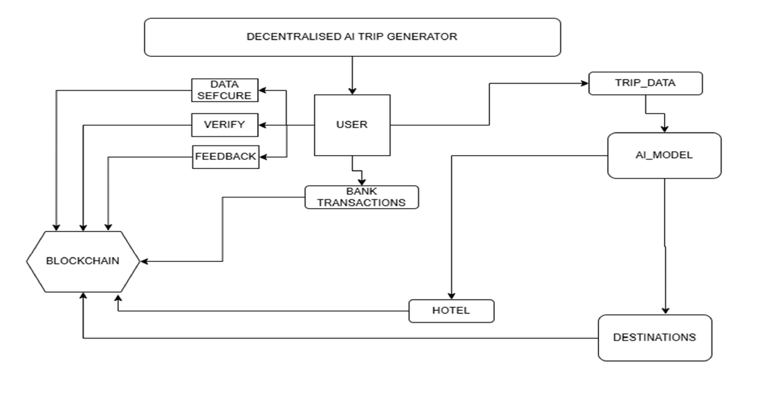

### System Architecture

#### Front-End

* 1. Developed using React, HTML, CSS for a responsive interface.

#### Back-End

* 1. Developed using Firebase, NodeJS and ExpressJS to handle API requests.

#### Database

* 1. Firebase for efficient data storage.

1. **Blockchain**
   1. Solidity

# Other Requirements

### Legal and Ethical Concerns

* + - **Data Privacy & Compliance** – Ensures adherence to **GDPR, CCPA, and HIPAA** by securely handling user data on decentralized networks.
    - **Blockchain Security & Fraud Prevention** – Implements **smart contract audits and encryption** to prevent fraud, hacking, and unauthorized access.
    - **Ethical AI Usage** – Ensures AI-generated itineraries are **fair, unbiased, and do not promote unethical tourism practices**.
    - **Regulatory Compliance for Payments** – Adheres to **international financial regulations** for cryptocurrency transactions and anti-money laundering (AML) policies.
    - **User Safety & Liability** – Establishes **clear policies on AI recommendations, travel bookings, and smart contract failures** to protect users from risks.

### Assumptions and Dependencies

* + - **Reliable Decentralized Infrastructure** – Assumes the availability of stable and efficient **blockchain networks and decentralized storage systems** for secure data management and transactions.
    - **AI Model Accuracy** – Assumes that AI models can provide **reliable and accurate travel recommendations** based on real-time data, user preferences, and external factors.
    - **User Adoption of Decentralized Payments** – Depends on users and service providers **accepting cryptocurrency and smart contract-based transactions** for seamless payments and bookings.
    - **Third-Party API Availability** – Relies on **external travel APIs, weather services, and transport providers** for real-time data updates and accurate itinerary adjustments.
    - **Legal and Regulatory Compliance** – Assumes the platform can **adapt to changing laws and regulations** related to blockchain, data privacy, and decentralized finance (DeFi) without major operational issues.